INDEX

Sl No | Name of the program | Date | Page No | Remarks
1 | Create your class time table using table tag |  | 3
2 | ‭Design‬ ‭a‬ ‭Webpage‬ ‭for‬ ‭your‬ ‭college‬ ‭containing‬ ‭description‬ ‭of‬ ‭courses,‬  department, faculties, library etc. using list tags, href tags, and anchor tags
3 | Create Your Resume using HTML. Use text, link, and lists
4 | ‭Create a Web Page of a supermarket using (internal CSS)
5 | Use Inline CSS to format your resume that you have created
6 | ‭Use External CSS to format your time table created
7 | Use‬ ‭all‬ ‭the‬ ‭CSS‬ ‭(inline,‬ ‭internal‬ ‭and‬ ‭external)‬ ‭to‬ ‭format‬ ‭the‬ ‭college‬ ‭web‬  page that you have created
8 | Write a HTML Program to create your college website for mobile device
9 | Write an HTML/JavaScript page to create a login page with validations
10 | Develop‬‭ a‬‭ Simple‬‭ calculator‬‭ for‬‭ addition,‬‭ subtraction,‬‭ multiplication‬‭ and‬  division operation using JavaScript
11 | Use Regular Expressions for validations in Login Page using JavaScript
12 | Write‬ ‭a‬ ‭Program‬ ‭to‬ ‭retrieve‬ ‭date‬ ‭from‬ ‭a‬ ‭text‬ ‭file‬ ‭and‬ ‭display‬ ‭it‬ ‭using‬ AJAX
13 | Create‬ ‭a‬ ‭web‬ ‭page‬ ‭using ‬‭Frame‬‭ with‬‭ rows ‬‭and‬‭ columns ‬‭where‬‭ we ‬‭will‬ have‬ ‭header‬ ‭frame,‬ ‭left‬ ‭frame,‬ ‭right‬ ‭frame,‬ ‭and‬ ‭status‬ ‭bar‬ ‭frame.‬ ‭On‬ clicking in the left frame, information should be displayed in the right frame

Program 1

Aim

Create your class time table using table tag.

Program

<!DOCTYPE html>
<html>
<head>
<title>time table</title>
</head>
<body>
<table border="3">
<caption>
<details>
<summary>Time Table</summary>
<p>This table provides the time table of BCA stream</p>
</details>
</caption>
<tr>
<th> </th>
<th>Hour 1 </th>
<th>Hour 2 </th>
<th>Hour 3 </th>
<th>Hour 4 </th>
<th>Hour 5 </th>
</tr>
<tr>
<th>Day 1</th>
<td>DS</td>
<td>OS</td>
<td>IC</td>
<td>WT</td>
<td>WT</td>
</tr>
<tr>
<th>Day 2</th>
<td>Hindi/Malyalam</td>
<td>DS</td>
<td>OS</td>
<td>Maths</td>
<td>Maths</td>
</tr>
<tr>
<th>Day 3</th>
<td>DS</td>
<td>English</td>
<td>Hindi/Malayalam</td>
<td>WT</td>
<td>OS</td>
</tr>
<tr>
<th>Day 4</th>
<td>OS</td>
<td>Maths</td>
<td>IC</td>
<td>English</td>
<td>Hindi/Malayalam</td>
</tr>
<tr>
<th>Day 5</th>
<td>DS</td>
<td>Maths</td>
<td>English</td>
<td>DS</td>
<td>DS</td>
</tr>

</table>
</body>
</html>

Output
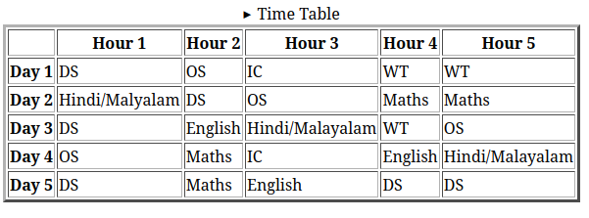

Program 2

Aim
Design a Webpage for your college containing description of courses, department, faculties, library etc. using list tags, href tags, and anchor tags.

Program

<!DOCTYPE html>
<html>
<head>
<title>St.Georges's College Aruvithura</title>
</head>
<body>
<center>
<h1><u>St.George's College Aruvithura</u></h1>
</center>
<br><br>
<nav>
<ul>
<li><a href="#about">About</a></li>
<li><a href="#course">Courses</a></li>
<li><a href="#department">Departments</a></li>
<li><a href="#resources">Resources</a></li>
</ul>
</nav>

<div id="about">
<h2>About</h2>
<p>St. George's College Aruvithura is a college under Mahatma Gandhi University, Kottayam. It is located in Aruvithura, Erattupetta, Kottayam District in Kerala, India. It was reaccredited with 'A++' Grade by NAAC for seven years in the fourth cycle.

St. George’s College Aruvithura, is a minority educational institution founded by St. George Forane Church, Aruvithura in 1965. Pioneered under the patronage of His Excellency Mar Sebastian Vayalil, the first Bishop of Pala, and cherished by a host of visionaries and philanthropists like Very Rev. Fr. Thomas Araythinal and Mr T. A. Thomman (Former Minister), the college, right from its inception, embarked on an odyssey towards academic pre-eminence. Very Rev. Fr. Thomas Manakkat, the founding manager and a great visionary, was truly instrumental in laying the foundations for a great beginning and Very Rev. Fr. Jacob Thazhathel, who followed him, was equally adept and insightful in his ideals, guiding the college during the early stages of its growth. For more than two decades, His Excellency Mar Joseph Pallickaparampil, the Bishop of Pala, had been the patron of the college. His Excellency Mar Joseph Kallarangattu is the present patron of this seat of learning.

Currently, the college offers 17 undergraduate courses, and 5 postgraduate courses and the Department of Chemistry and Physics are recognized Research Centers under MG University</p>
</div>
<div id="course">
<h2>Courses</h2>
<h3>UG</h3>
<h4>Aided</h4>
<ol>
<li>B.Sc (Honours) Mathematics</li>
<li>B.Sc (Honours) Physics with specialization in Computational Physics and Semiconductor Physics</li>
<li>B.Sc (Honours) Chemistry</li>
<li>B.Sc (Honours) Botany</li>
<li>B.A (Honours) Economics</li>
<li>B.A (Honours) Political Science</li>
<li>B A (Honours) English with Specialization in Media Studies & Film Studies </li>
<li>B.Com (Honours) with Specialization in Finance & Taxation</li>
<li>BCA (Honours)</li>
</ol>
<h4>Self-Financing</h4>
<ol>
<li>B.Com (Honours) with Specialization in Finance & Taxation</li>
<li>B.Com (Honours) with Specialization in Accounting</li>
<li>B.Com (Honours) with Specialization in Marketing</li>
<li>B.Com (Honours) with Specialization in Financial Markets</li>
<li>B.Com (Honours) with Specialization in Co-operation</li>
<li>B.A (Honours) Journalism & Mass Communication</li>
<li>B.Sc (Honours) Food Science & Quality Control with specialization in Food Saftey</li>
<li>B.Voc Food Technology & Analysis</li>
<li>BCA (Honours)</li>
</ol>
<h3>PG</h3>
<h4>Aided</h4>
<ol>
<li>M.Sc. Physics</li>
<li>M. Sc. Chemistry</li>
<li>Integrated MA English</li>

</ol>
<h4>Self-Financing</h4>
<ol>
<li>M.Sc. Food Technology and Quality Assurance</li>
<li>M.Com Finance and Taxation</li>
</ol>
</div>
<div id="department">
<h2>Departments</h2>
<ul>
<li><a href="bca.html" target="_blank">Department of Computer Applications (Aided)</a></li>
<li>Department of Botany and Zoology</li>
<li>Department of Chemistry</li>
<li>Department of Commerce (Aided)</li>
<li>Department of Commerce (SF)</li>
<li>Department of Computer Applications (Aided)</li>
<li>Department of Computer Applications (SF) </li>
<li>Department of Economics</li>
<li>Department of English (Aided)</li>
<li>Department of English(SF)</li>
</ul>
</div>
<div id="resources">
<h2>Resources</h2>
<h3>Library</h3>
<p>The library at St. George's College, Aruvithura, has a rich history, having started functioning in 1965. Over the years, it has undergone significant upgrades and expansion to become a first-grade library. In 1978, the post of a first-grade Librarian and a IV-grade librarian were sanctioned, indicating the growing importance of the library as a vital academic resource.

Today, the library has a vast collection of resources to support the academic programs of the college. There are 32,330 books available on various subjects, including literature, science, technology, history, and philosophy. The library also has 58 periodicals, 250 CDs, and access to 8 newspapers, providing students and staff with access to the latest research and developments in their fields of interest.

In addition to the regular collection, the library also provides resources specifically for academic support programs. 400 books are allotted for Walk with Scholar Programme and Scholar Support Programme. The library is a member of the National Digital Library of India (NDLI) and provides access to the NLIST facility, which provides access to electronic resources, including books, journals, and databases.

The library is equipped with computers and provides internet access to students and staff, making it easy for them to search for academic resources and research materials online. The library also offers repographic facilities, allowing students to make copies of materials that they need.

To facilitate easy access to its vast collection, the library uses an Online Public Access Catalogue (OPAC). Users can search for books, journals, and other materials using the OPAC, making it easy to locate and retrieve resources.

At St. George's College, Aruvithura, the library is a valuable resource for the academic community. Its collection of resources, including books, journals, and electronic resources, provides a wealth of knowledge to students and staff. The library's commitment to providing access to the latest research and developments in different fields ensures that it remains a vital component of the college's academic programs.
</p>
</div>
</body>
</html>

Output

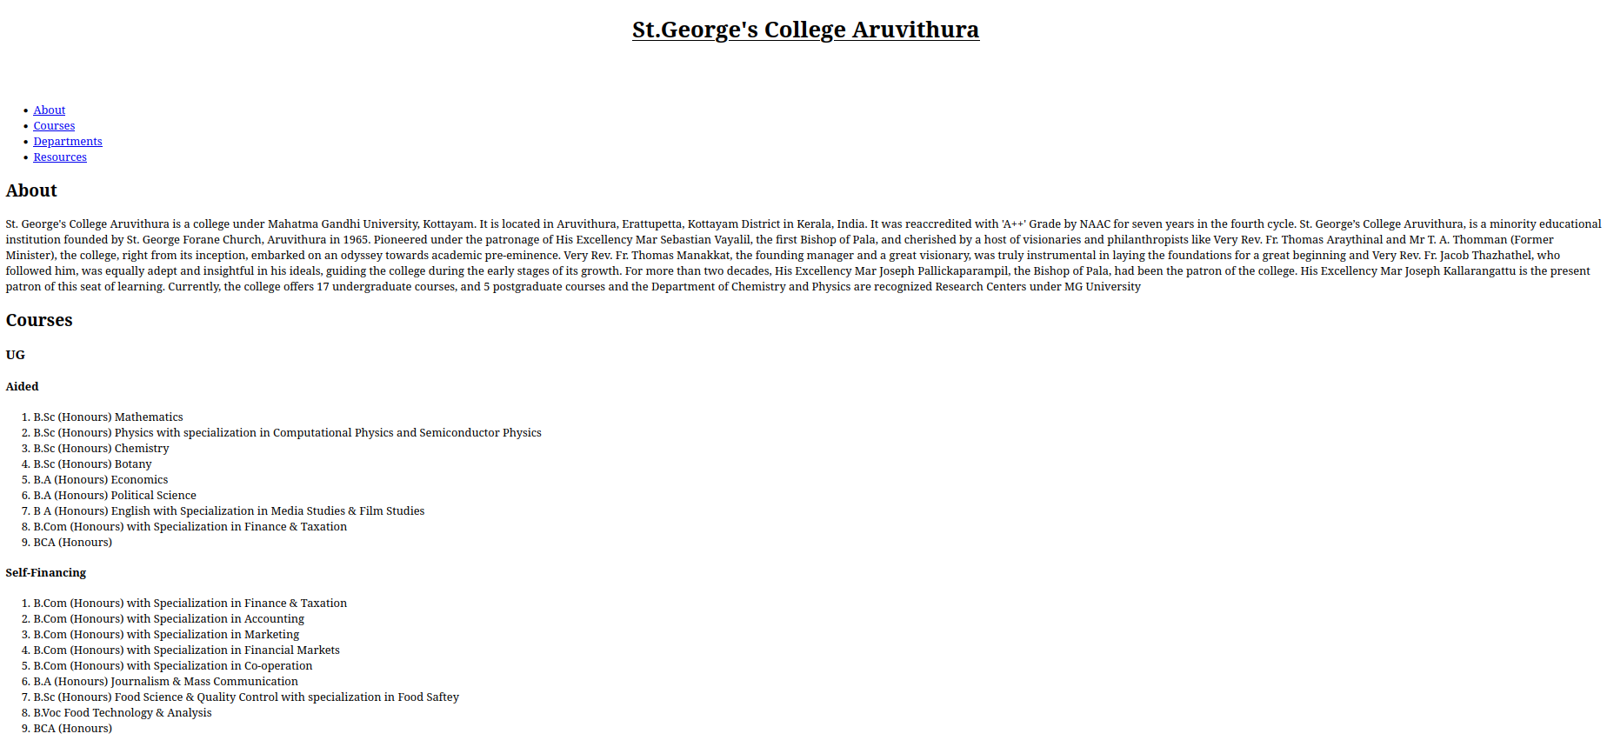

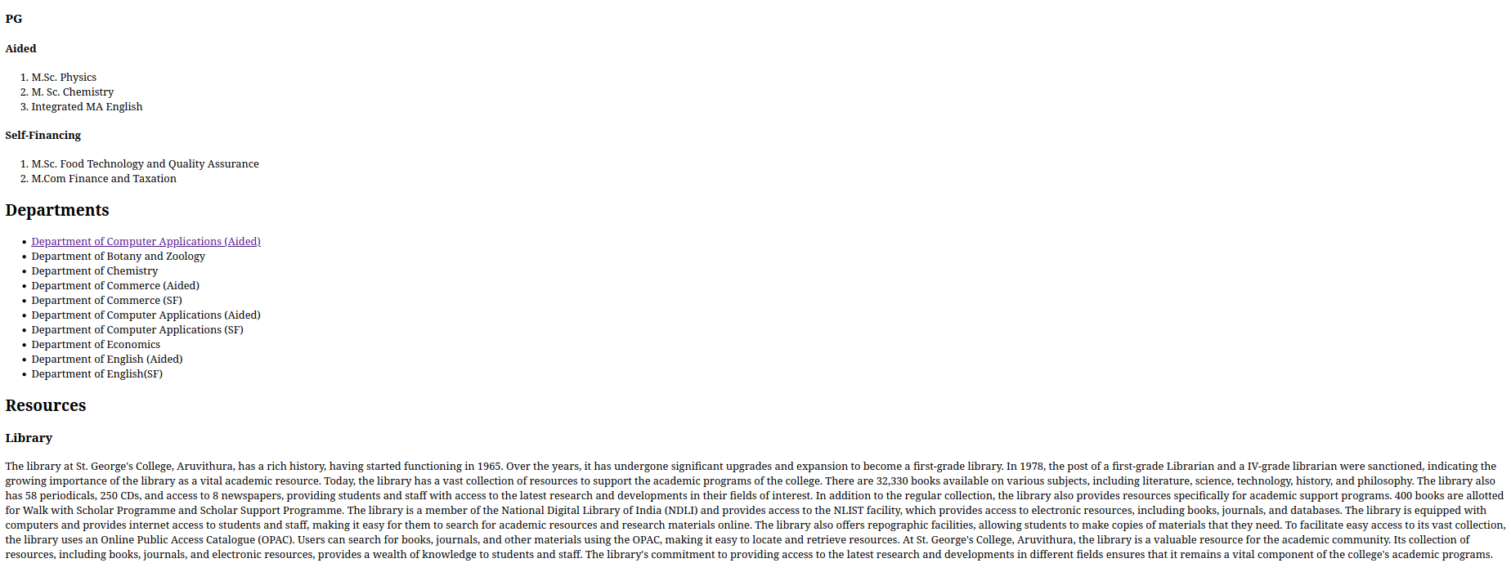

Program 3

Aim
Create your Resume using HTML .Use text,link,and lists.

Program

<!DOCTYPE html>
<html>
<head>
<title>Resume</title>
</head>
<body>
<h1>Abhiram N Namboothiri</h1>
<p>Email:<a href="abhiramnnamboothiri58@gmail.com">abhiramnnamboothiri58@gmail.com</a> | github:<a href="https://github.com/abhiram2030">Abhiram</a> | Linkedin:<a href="linkedin.com">abhiram</a></p>
<br>
<h2>EDUCATION</h2>
<hr>
<br>
<h3>St.George's college Aruvithura</h3>
<p>Bachelor of Computer Application (2024 0nwards)</p>
<br>
<h3>Holy Cross HSS Cherpunkal</h3>
<p>Higher Secondary Education in Computer Science(2024)|98%</p>
<br>
<h3>SKVHSS Kurichithanam</h3>
<p>SSLC-2022|99%</p>
<br>
<br>
<h2>Skills And Activities</h2>
<hr>
<ul>
<li>Programming languages:Python,C/C++,java</li>
<li>Web Development:HTML,CSS,PHP</li>
<li>Good Communication skill</li>
<li>Leadership</li>
<li>NCC CADET -CDT</li>
</ul>
<br>
<h2>Achievements</h2>
<hr>
<br>
<ul>
<li>Plus Two Full A+</li>
<li>SSLC Full A+</li>
<li>NCC-A Certificate</li>
</ul>
<br>
<h2>Languages</h2>
<hr>
<br>
<ul>
<li>Malayalam</li>
<li>English</li>
<li>Hindi</li>
<li>Tamil</li>
</ul>
<br>
<h2>Hobbies</h2>
<hr>
<br>
<ul>
<li>Reading</li>
<li>football</li>
<li>music listening</li>
</ul>

</body>
</html>

Output

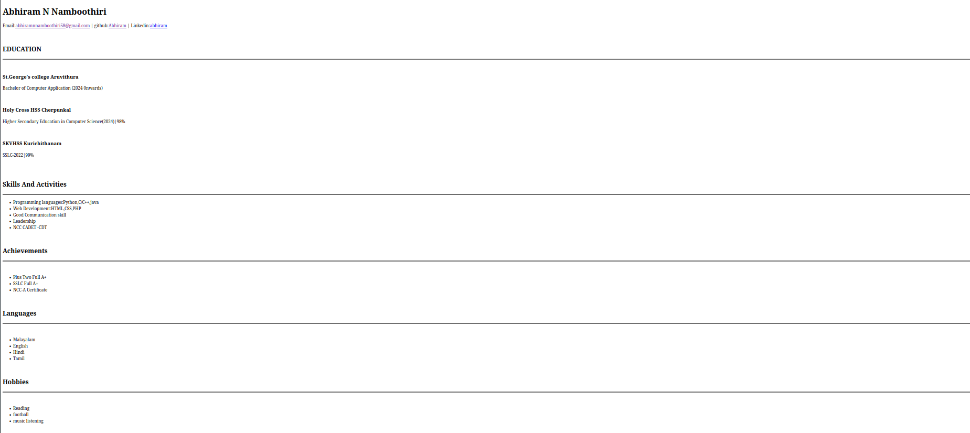

Program 4

Aim
Create a Web Page of a supermarket using (internal CSS).

Program

<!DOCTYPE html>
<html>
<head>
<title>SUPERMART</title>
<style>
#head{
background-color:#0078ff;
padding:30px;
}
h1{
font-weight:bold;
text-align:center;
font-size:40px;
color:white;
}
nav{
text-align:center;
font-size:20px;
font-weight:bold;
}
a{
color:black;
text-decoration:none;
margin:40px;
}
#cont{
background-color:gold;
font-weight:bold;
padding:30px;
margin:0;
}
#h2{
text-align:center;
font-size:25px;
color:purple;
font-weight:bold;

}
body{
margin:0;
}
#sub{
text-align:center;
font-weight:bold;
font-size:25px;
}
#off{
text-align:center;
font-weight:bold;
font-size:25px;
color:white;
}
#offers{
background-color:green;
padding:30px;

}
.des{
text-align:center;
font-size:15px;
font-weight:bold;
}
.50{
font-size:20px;
border:2px white;
}
.element{
font-weight:bold;
}
footer{
background-color:purple;
padding:30px;
text-align:center;
color:white;
}
.add{
font-weight:bold;
}
#products{
text-align:center;
padding:30px;
}
.res{
border: 2px solid #0078FF;
border-radius: 10px;
padding: 20px;
width: 200px;
display:inline-block;
margin:15px;
font-weight:bold;
font-size:18px;
}
.res img{
width:200px;
border-radius:10px;
}
#pro{
background-color:black;
color:blue;
padding:10px;
font-size:35px;
border-radius:10px;
}

</style>

</head>
<body>
<div id="head">
<h1>SUPERMART</h1>
<nav>
<a href="#products">Products</a>
<a href="#offers">Offers</a>
<a href="#contact">Contact</a>
</nav>
</div>
<div id="cont">
<h2 id="h2">"Save big,Shop smart!"</h2>
<p>
Experience the ultimate shopping convenience at Supermart. Our supermarket offers a vast array of products, from fresh fruits and vegetables to packaged goods and household items, all under one roof.
</p>
</div>
<div id="products">
<h2 id="sub">OUR <span id="pro">PRODUCTS</span></h2>
<div class="res">
<img src="https://www.healthyeating.org/images/default-source/home-0.0/nutrition-topics-2.0/general-nutrition-wellness/2-2-2-3foodgroups_fruits_detailfeature.jpg?sfvrsn=64942d53_4">
Fruits
</div>
<div class="res">
<img src="https://media.istockphoto.com/id/1409236261/photo/healthy-food-healthy-eating-background-fruit-vegetable-berry-vegetarian-eating-superfood.jpg?s=612x612&w=0&k=20&c=kYZKgwsQbH_Hscl3mPRKkus0h1OPuL0TcXxZcO2Zdj0=" style="width:172px;">
Vegetables
</div>
<div class="res">
<img src="https://t4.ftcdn.net/jpg/01/45/60/21/360_F_145602173_05uVexifBuCvWIKvsHGWNuIpPtp5ShkI.jpg" style="width:184px;">
Dairy Products
</div>
<div class="res">
<img src="https://yummy-valley.com/wp-content/uploads/2024/03/Murukku.webp">
Snacks
</div>
</div>
<div id="offers">
<h2 id="off">Special Offers</h2>
<p class="des">Get a free gift voucher on purchases above ₹2000!</p>
<p class="des">Get up to 50% OFF on selected items. Hurry, limited stock!</p>
</div>
<div id="contact">
<footer>
<p>Contact us at: <span class="element">supermart@gmail.com</span> | Phone: <span class="element">+919876435648</span></p>
<p>Follow us on:
<a class="add" href="#">Facebook</a> |
<a class="add" href="#">Instagram</a> |
<a class="add" href="#">Twitter</a>
</p>
</footer>
</div>
</body>
</html>

Output

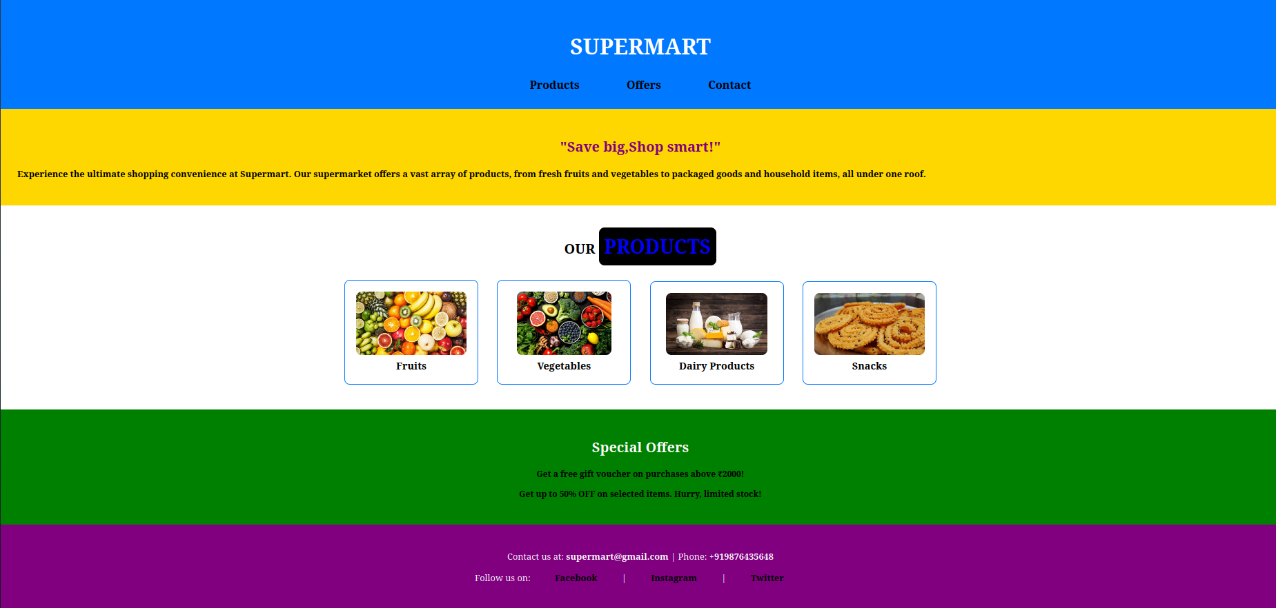

Program 5

Aim
Use inline css to format your Resume that you have created.

Program

<!DOCTYPE html>
<html>
<head>
<title>Resume</title>
</head>
<body>
<div style="border:3px solid black; padding:20px;">
<div style="background-color:#bf3722; text-align:center;padding:10px;font-weight:bold; font-size:18px;">
<h1 style="color:white; font-weight:bold;font-size:40px;">Abhiram N Namboothiri</h1>
<p>Email:<a style="color:#00ffff; font-size:15px;font-weight:bold;"href="abhiramnnamboothiri58@gmail.com">abhiramnnamboothiri58@gmail.com</a> | github:<a style="color:#00ffff; font-size:15px;font-weight:bold;" href="https://github.com/abhiram2030">Abhiram</a> | Linkedin:<a style="color:#00ffff; font-size:15px;font-weight:bold;"href="linkedin.com">abhiram</a></p>
</div>
<h2 style="font-size:30px;">EDUCATION</h2>
<hr>
<h3 style="font-size:20px;">St.George's college Aruvithura</h3>
<p>Bachelor of Computer Application (2024 0nwards)</p>
<h3 style="font-size:20px;">Holy Cross HSS Cherpunkal</h3>
<p>Higher Secondary Education in Computer Science(2024)|98%</p>
<h3 style="font-size:20px;">SKVHSS Kurichithanam</h3>
<p>SSLC-2022|99%</p>
<h2 style="font-size:30px;">Skills And Activities</h2>
<hr>
<ul>
<li>Programming languages:Python,C/C++,java</li>
<li>Web Development:HTML,CSS,PHP</li>
<li>Good Communication skill</li>
<li>Leadership</li>
<li>NCC CADET -CDT</li>
</ul>
<h2 style="font-size:30px;">Achievements</h2>
<hr>
<ul>
<li>Plus Two Full A+</li>
<li>SSLC Full A+</li>
<li>NCC-A Certificate</li>
</ul>
<h2 style="font-size:30px;">Languages</h2>
<hr>
<ul>
<li>Malayalam</li>
<li>English</li>
<li>Hindi</li>
<li>Tamil</li>
</ul>
<h2 style="font-size:30px;">Hobbies</h2>
<hr>
<ul>
<li>Reading</li>
<li>football</li>
<li>music listening</li>
</ul>
<div>

</body>
</html>

Output
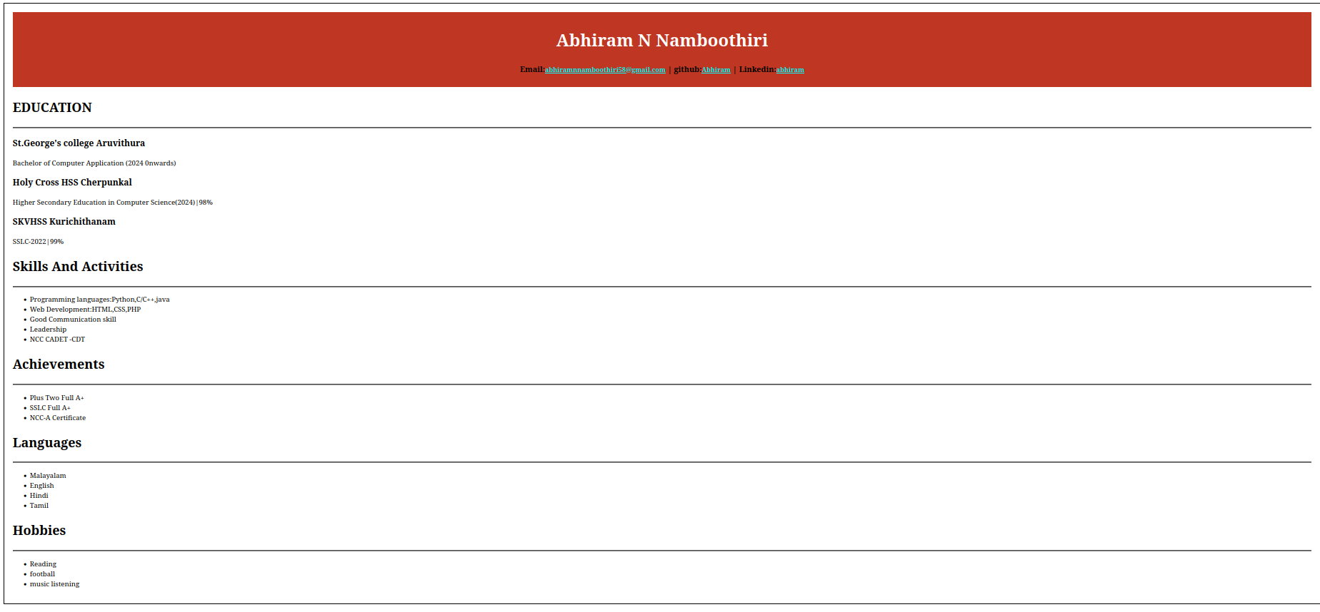

Program 6

Aim
Use External CSS to format your time table created.

Program

HTML

<!DOCTYPE html>
<html>
<head>
<title>time table</title>
<link rel="stylesheet" href="style6.css"/>
</head>
<body>
<table border="3">
<caption>
<details>
<summary>Time Table</summary><br><br>
<p>This table provides the time table of BCA stream</p>
</details>
</caption>
<tr>
<th> </th>
<th>Hour 1 </th>
<th>Hour 2 </th>
<th>Hour 3 </th>
<th>Hour 4 </th>
<th>Hour 5 </th>
</tr>
<tr>
<th>Day 1</th>
<td>DS</td>
<td>OS</td>
<td>IC</td>
<td>WT</td>
<td>WT</td>
</tr>
<tr>
<th>Day 2</th>
<td>Hindi/Malyalam</td>
<td>DS</td>
<td>OS</td>
<td>Maths</td>
<td>Maths</td>
</tr>
<tr>
<th>Day 3</th>
<td>DS</td>
<td>English</td>
<td>Hindi/Malayalam</td>
<td>WT</td>
<td>OS</td>
</tr>
<tr>
<th>Day 4</th>
<td>OS</td>
<td>Maths</td>
<td>IC</td>
<td>English</td>
<td>Hindi/Malayalam</td>
</tr>
<tr>
<th>Day 5</th>
<td>DS</td>
<td>Maths</td>
<td>English</td>
<td>DS</td>
<td>DS</td>
</tr>

</table>
</body>
</html>

CSS

th{
color:white;
background-color:blue;
height:50px;
width:60px;
font-style:bold;
font-size:30px;
}
td{
background-color:#c0c0c0;
text-align:center;
font-style:bold;
font-size:25px;
padding:10px;

}
table,th,td{
border:3px solid black;
border-collapse:collapse;
}
table{
width:100%;
}
summary{
font-size:40px;
font-style:bold;
text-decoration:underline;
}
body{
background-color:#00ffff;
}
p{
border:7px;
background-color:#fd5c9d;
}

Output
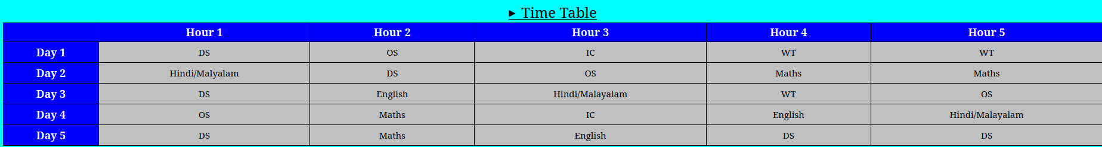

Program 7

Aim
Use all the css ( inline,internal and external ) to format the college web page that you have created

Program

HTML

<!DOCTYPE html>
<html>
<head>
<title>St.Georges's College Aruvithura</title>
<link rel="stylesheet" href="style7.css"/>
<style>
#part{
background-color:white;
padding:20px;
margin:15px;
}
</style>
</head>
<body>
<h1 style=" text-align:center;font-size:40px; color:white;"><u>St.George's College Aruvithura</u></h1>
<br><br>
<center>
<nav>
<ul>
<li class="con"><a href="#about">About</a></li>
<li class="con"><a href="#course">Courses</a></li>
<li class="con"><a href="#department">Departments</a></li>
<li class="con"><a href="#resources">Resources</a></li>
</ul>
</nav>
</center>
<div id="part">
<br><br>

<div id="about">
<h2>About</h2>
<p>St. George's College Aruvithura is a college under Mahatma Gandhi University, Kottayam. It is located in Aruvithura, Erattupetta, Kottayam District in Kerala, India. It was reaccredited with 'A++' Grade by NAAC for seven years in the fourth cycle.

St. George’s College Aruvithura, is a minority educational institution founded by St. George Forane Church, Aruvithura in 1965. Pioneered under the patronage of His Excellency Mar Sebastian Vayalil, the first Bishop of Pala, and cherished by a host of visionaries and philanthropists like Very Rev. Fr. Thomas Araythinal and Mr T. A. Thomman (Former Minister), the college, right from its inception, embarked on an odyssey towards academic pre-eminence. Very Rev. Fr. Thomas Manakkat, the founding manager and a great visionary, was truly instrumental in laying the foundations for a great beginning and Very Rev. Fr. Jacob Thazhathel, who followed him, was equally adept and insightful in his ideals, guiding the college during the early stages of its growth. For more than two decades, His Excellency Mar Joseph Pallickaparampil, the Bishop of Pala, had been the patron of the college. His Excellency Mar Joseph Kallarangattu is the present patron of this seat of learning.

Currently, the college offers 17 undergraduate courses, and 5 postgraduate courses and the Department of Chemistry and Physics are recognized Research Centers under MG University</p>
</div>
<div id="course">
<h2>Courses</h2>
<h3>UG</h3>
<h4>Aided</h4>
<ol>
<li>B.Sc (Honours) Mathematics</li>
<li>B.Sc (Honours) Physics with specialization in Computational Physics and Semiconductor Physics</li>
<li>B.Sc (Honours) Chemistry</li>
<li>B.Sc (Honours) Botany</li>
<li>B.A (Honours) Economics</li>
<li>B.A (Honours) Political Science</li>
<li>B A (Honours) English with Specialization in Media Studies & Film Studies </li>
<li>B.Com (Honours) with Specialization in Finance & Taxation</li>
<li>BCA (Honours)</li>
</ol>
<h4>Self-Financing</h4>
<ol>
<li>B.Com (Honours) with Specialization in Finance & Taxation</li>
<li>B.Com (Honours) with Specialization in Accounting</li>
<li>B.Com (Honours) with Specialization in Marketing</li>
<li>B.Com (Honours) with Specialization in Financial Markets</li>
<li>B.Com (Honours) with Specialization in Co-operation</li>
<li>B.A (Honours) Journalism & Mass Communication</li>
<li>B.Sc (Honours) Food Science & Quality Control with specialization in Food Saftey</li>
<li>B.Voc Food Technology & Analysis</li>
<li>BCA (Honours)</li>
</ol>
<h3>PG</h3>
<h4>Aided</h4>
<ol>
<li>M.Sc. Physics</li>
<li>M. Sc. Chemistry</li>
<li>Integrated MA English</li>

</ol>
<h4>Self-Financing</h4>
<ol>
<li>M.Sc. Food Technology and Quality Assurance</li>
<li>M.Com Finance and Taxation</li>
</ol>
</div>
<div id="department">
<h2>Departments</h2>
<ul>
<li><a href="bca-css.html" target="_blank">Department of Computer Applications (Aided)</a></li>
<li>Department of Botany and Zoology</li>
<li>Department of Chemistry</li>
<li>Department of Commerce (Aided)</li>
<li>Department of Commerce (SF)</li>
<li>Department of Computer Applications (Aided)</li>
<li>Department of Computer Applications (SF) </li>
<li>Department of Economics</li>
<li>Department of English (Aided)</li>
<li>Department of English(SF)</li>
</ul>
</div>
<div id="resources">
<h2>Resources</h2>
<h3>Library</h3>
<p>The library at St. George's College, Aruvithura, has a rich history, having started functioning in 1965. Over the years, it has undergone significant upgrades and expansion to become a first-grade library. In 1978, the post of a first-grade Librarian and a IV-grade librarian were sanctioned, indicating the growing importance of the library as a vital academic resource.

Today, the library has a vast collection of resources to support the academic programs of the college. There are 32,330 books available on various subjects, including literature, science, technology, history, and philosophy. The library also has 58 periodicals, 250 CDs, and access to 8 newspapers, providing students and staff with access to the latest research and developments in their fields of interest.

In addition to the regular collection, the library also provides resources specifically for academic support programs. 400 books are allotted for Walk with Scholar Programme and Scholar Support Programme. The library is a member of the National Digital Library of India (NDLI) and provides access to the NLIST facility, which provides access to electronic resources, including books, journals, and databases.

The library is equipped with computers and provides internet access to students and staff, making it easy for them to search for academic resources and research materials online. The library also offers repographic facilities, allowing students to make copies of materials that they need.

To facilitate easy access to its vast collection, the library uses an Online Public Access Catalogue (OPAC). Users can search for books, journals, and other materials using the OPAC, making it easy to locate and retrieve resources.

At St. George's College, Aruvithura, the library is a valuable resource for the academic community. Its collection of resources, including books, journals, and electronic resources, provides a wealth of knowledge to students and staff. The library's commitment to providing access to the latest research and developments in different fields ensures that it remains a vital component of the college's academic programs.
</p>
</div>
</div>
</body>
</html>

CSS

body{
background-color:red;
}
h2{
color:red;
font-weight:bold;
font-size:30px;
}
h3{
color:purple;
font-weight:bold;
font-size:25px;
}
h4{
color:blue;
font-weight:bold;
font-size:20px;
}
p{
font-size:15px;
font-weight:bold;
line-height:1.5;
}
li{
font-size:15px;
font-weight:bold;
line-height:1.5;
}

.con{
border:2px solid black;
background-color:gold;
padding:10px;
text-align:center;
width:400px;
font-size:20px;
font-weight:bold;

}
ul{
list-style-type:none;
padding:0;
}

Output

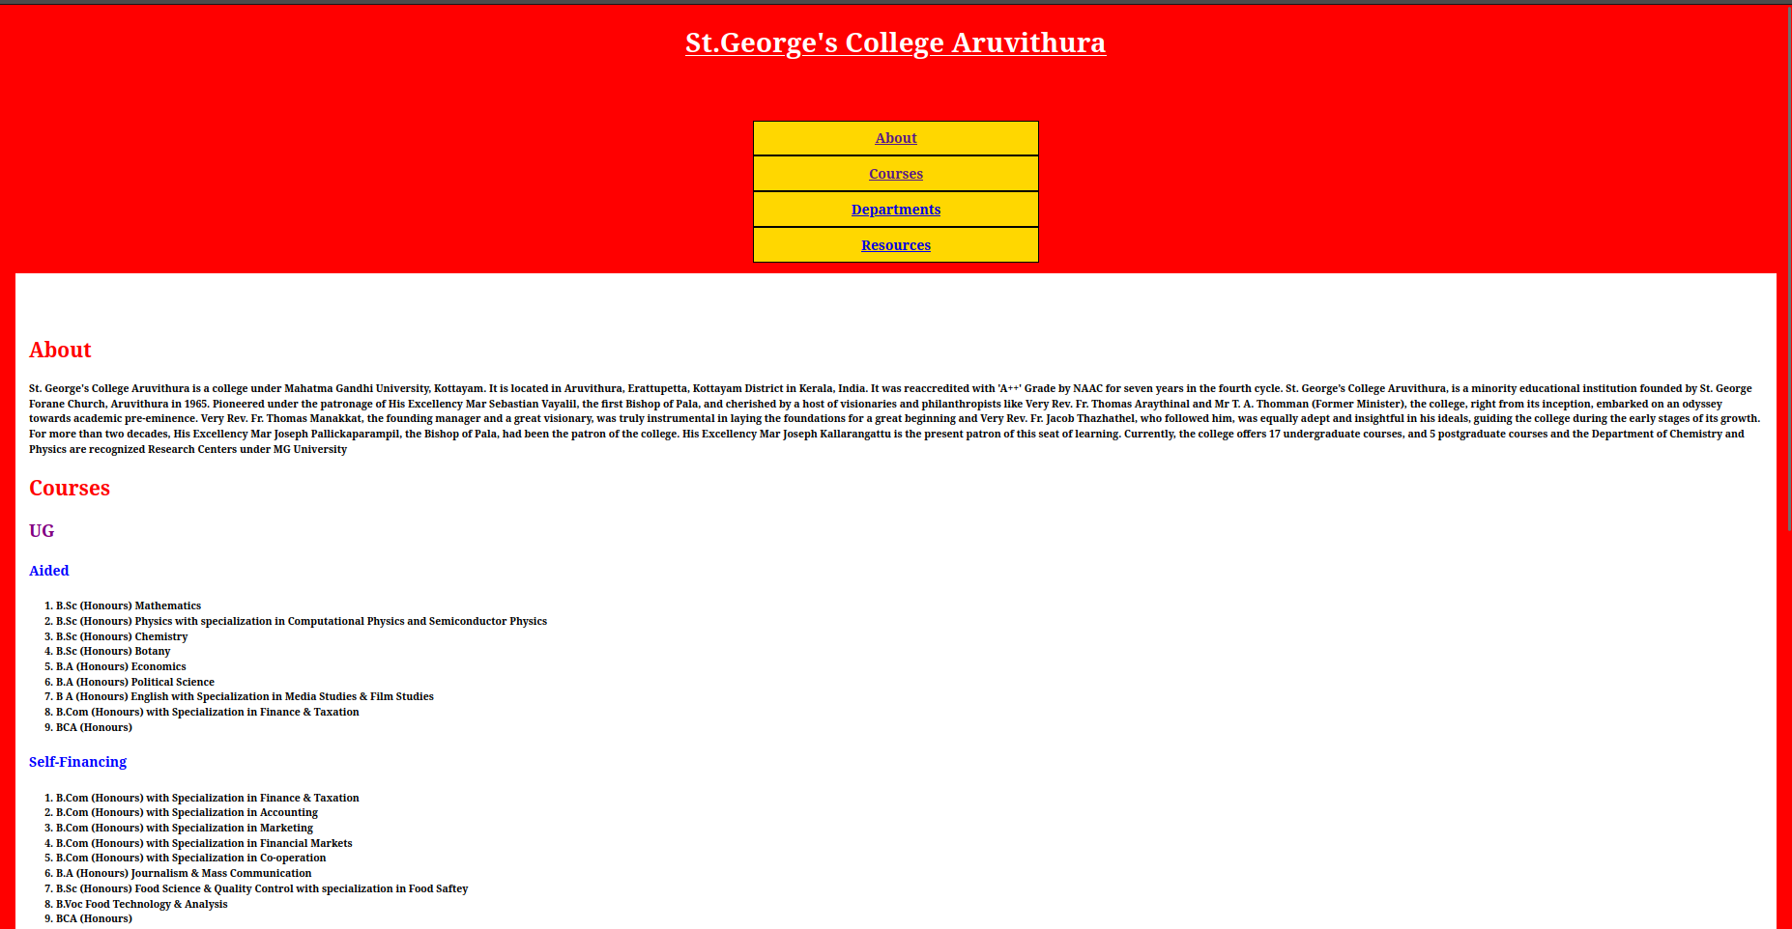
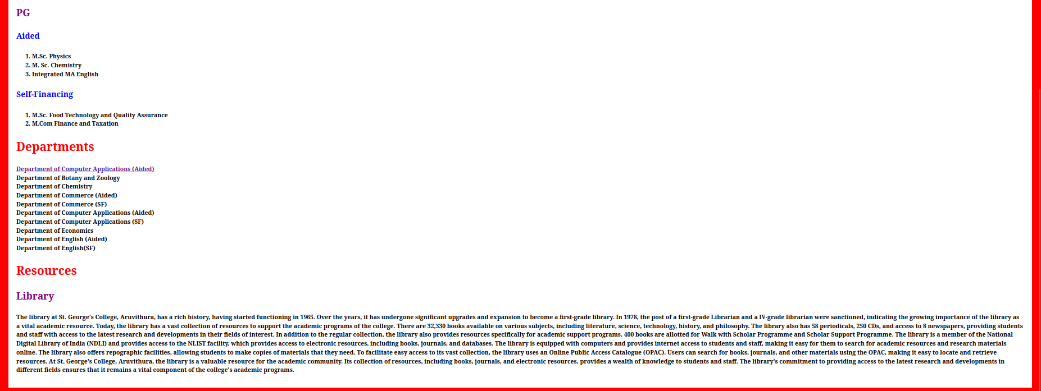

Program 8

Aim
Write a HTML program to create your college website using for mobile device.

Program

HTML

<!DOCTYPE html>
<html>
<head>
<title>St.Georges's College Aruvithura</title>
<link rel="stylesheet" href="style7.css"/>
<style>
#part{
background-color:white;
padding:20px;
margin:15px;
}
</style>
<meta name=”viewport” content=”width=device-width,initial-scale=1.0”/>

</head>
<body>
<h1 style=" text-align:center;font-size:40px; color:white;"><u>St.George's College Aruvithura</u></h1>
<br><br>
<center>
<nav>
<ul>
<li class="con"><a href="#about">About</a></li>
<li class="con"><a href="#course">Courses</a></li>
<li class="con"><a href="#department">Departments</a></li>
<li class="con"><a href="#resources">Resources</a></li>
</ul>
</nav>
</center>
<div id="part">
<br><br>

<div id="about">
<h2>About</h2>
<p>St. George's College Aruvithura is a college under Mahatma Gandhi University, Kottayam. It is located in Aruvithura, Erattupetta, Kottayam District in Kerala, India. It was reaccredited with 'A++' Grade by NAAC for seven years in the fourth cycle.

St. George’s College Aruvithura, is a minority educational institution founded by St. George Forane Church, Aruvithura in 1965. Pioneered under the patronage of His Excellency Mar Sebastian Vayalil, the first Bishop of Pala, and cherished by a host of visionaries and philanthropists like Very Rev. Fr. Thomas Araythinal and Mr T. A. Thomman (Former Minister), the college, right from its inception, embarked on an odyssey towards academic pre-eminence. Very Rev. Fr. Thomas Manakkat, the founding manager and a great visionary, was truly instrumental in laying the foundations for a great beginning and Very Rev. Fr. Jacob Thazhathel, who followed him, was equally adept and insightful in his ideals, guiding the college during the early stages of its growth. For more than two decades, His Excellency Mar Joseph Pallickaparampil, the Bishop of Pala, had been the patron of the college. His Excellency Mar Joseph Kallarangattu is the present patron of this seat of learning.

Currently, the college offers 17 undergraduate courses, and 5 postgraduate courses and the Department of Chemistry and Physics are recognized Research Centers under MG University</p>
</div>
<div id="course">
<h2>Courses</h2>
<h3>UG</h3>
<h4>Aided</h4>
<ol>
<li>B.Sc (Honours) Mathematics</li>
<li>B.Sc (Honours) Physics with specialization in Computational Physics and Semiconductor Physics</li>
<li>B.Sc (Honours) Chemistry</li>
<li>B.Sc (Honours) Botany</li>
<li>B.A (Honours) Economics</li>
<li>B.A (Honours) Political Science</li>
<li>B A (Honours) English with Specialization in Media Studies & Film Studies </li>
<li>B.Com (Honours) with Specialization in Finance & Taxation</li>
<li>BCA (Honours)</li>
</ol>
<h4>Self-Financing</h4>
<ol>
<li>B.Com (Honours) with Specialization in Finance & Taxation</li>
<li>B.Com (Honours) with Specialization in Accounting</li>
<li>B.Com (Honours) with Specialization in Marketing</li>
<li>B.Com (Honours) with Specialization in Financial Markets</li>
<li>B.Com (Honours) with Specialization in Co-operation</li>
<li>B.A (Honours) Journalism & Mass Communication</li>
<li>B.Sc (Honours) Food Science & Quality Control with specialization in Food Saftey</li>
<li>B.Voc Food Technology & Analysis</li>
<li>BCA (Honours)</li>
</ol>
<h3>PG</h3>
<h4>Aided</h4>
<ol>
<li>M.Sc. Physics</li>
<li>M. Sc. Chemistry</li>
<li>Integrated MA English</li>

</ol>
<h4>Self-Financing</h4>
<ol>
<li>M.Sc. Food Technology and Quality Assurance</li>
<li>M.Com Finance and Taxation</li>
</ol>
</div>
<div id="department">
<h2>Departments</h2>
<ul>
<li><a href="bca-css.html" target="_blank">Department of Computer Applications (Aided)</a></li>
<li>Department of Botany and Zoology</li>
<li>Department of Chemistry</li>
<li>Department of Commerce (Aided)</li>
<li>Department of Commerce (SF)</li>
<li>Department of Computer Applications (Aided)</li>
<li>Department of Computer Applications (SF) </li>
<li>Department of Economics</li>
<li>Department of English (Aided)</li>
<li>Department of English(SF)</li>
</ul>
</div>
<div id="resources">
<h2>Resources</h2>
<h3>Library</h3>
<p>The library at St. George's College, Aruvithura, has a rich history, having started functioning in 1965. Over the years, it has undergone significant upgrades and expansion to become a first-grade library. In 1978, the post of a first-grade Librarian and a IV-grade librarian were sanctioned, indicating the growing importance of the library as a vital academic resource.

Today, the library has a vast collection of resources to support the academic programs of the college. There are 32,330 books available on various subjects, including literature, science, technology, history, and philosophy. The library also has 58 periodicals, 250 CDs, and access to 8 newspapers, providing students and staff with access to the latest research and developments in their fields of interest.

In addition to the regular collection, the library also provides resources specifically for academic support programs. 400 books are allotted for Walk with Scholar Programme and Scholar Support Programme. The library is a member of the National Digital Library of India (NDLI) and provides access to the NLIST facility, which provides access to electronic resources, including books, journals, and databases.

The library is equipped with computers and provides internet access to students and staff, making it easy for them to search for academic resources and research materials online. The library also offers repographic facilities, allowing students to make copies of materials that they need.

To facilitate easy access to its vast collection, the library uses an Online Public Access Catalogue (OPAC). Users can search for books, journals, and other materials using the OPAC, making it easy to locate and retrieve resources.

At St. George's College, Aruvithura, the library is a valuable resource for the academic community. Its collection of resources, including books, journals, and electronic resources, provides a wealth of knowledge to students and staff. The library's commitment to providing access to the latest research and developments in different fields ensures that it remains a vital component of the college's academic programs.
</p>
</div>
</div>
</body>
</html>

CSS

body{
background-color:red;
}
h2{
color:red;
font-weight:bold;
font-size:30px;
}
h3{
color:purple;
font-weight:bold;
font-size:25px;
}
h4{
color:blue;
font-weight:bold;
font-size:20px;
}
p{
font-size:15px;
font-weight:bold;
line-height:1.5;
}
li{
font-size:15px;
font-weight:bold;
line-height:1.5;
}

.con{
border:2px solid black;
background-color:gold;
padding:10px;
text-align:center;
width:400px;
font-size:20px;
font-weight:bold;

}
ul{
list-style-type:none;
padding:0;
}

Output

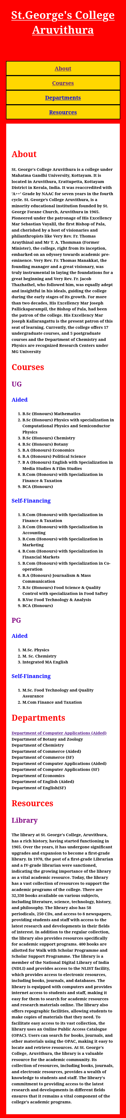

Program 9

Aim
Write an HTML/JavaScript page to create a login page with validations.

Program

HTML

<!DOCTYPE html>
<html>
<head>
<title>Login Page</title>
</head>
<body>
<h1> User-Login</h1>
Username:<input type="email"id="inp1"class="inp"><br><br>
Password:<input type="password" id="inp2" class="inp"><br><br>
<input type="button" value="submit" onclick="validate()">
<script src="script9.js"></script>
</body>
</html>

JavaScript

function validate(){
var username=document.getElementById("inp1").value;
var password=document.getElementById("inp2").value;
if(username.trim()==""||password.trim()=="")
{
alert("username or password is empty");
}
}

Output

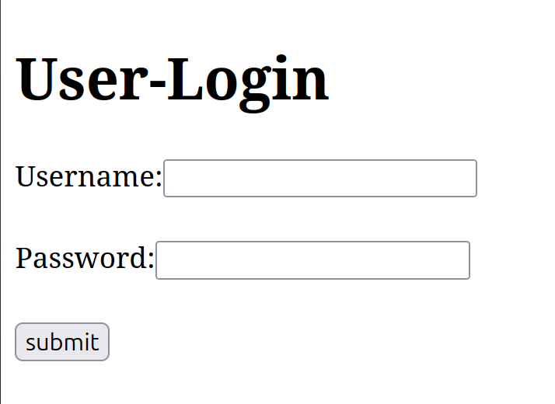

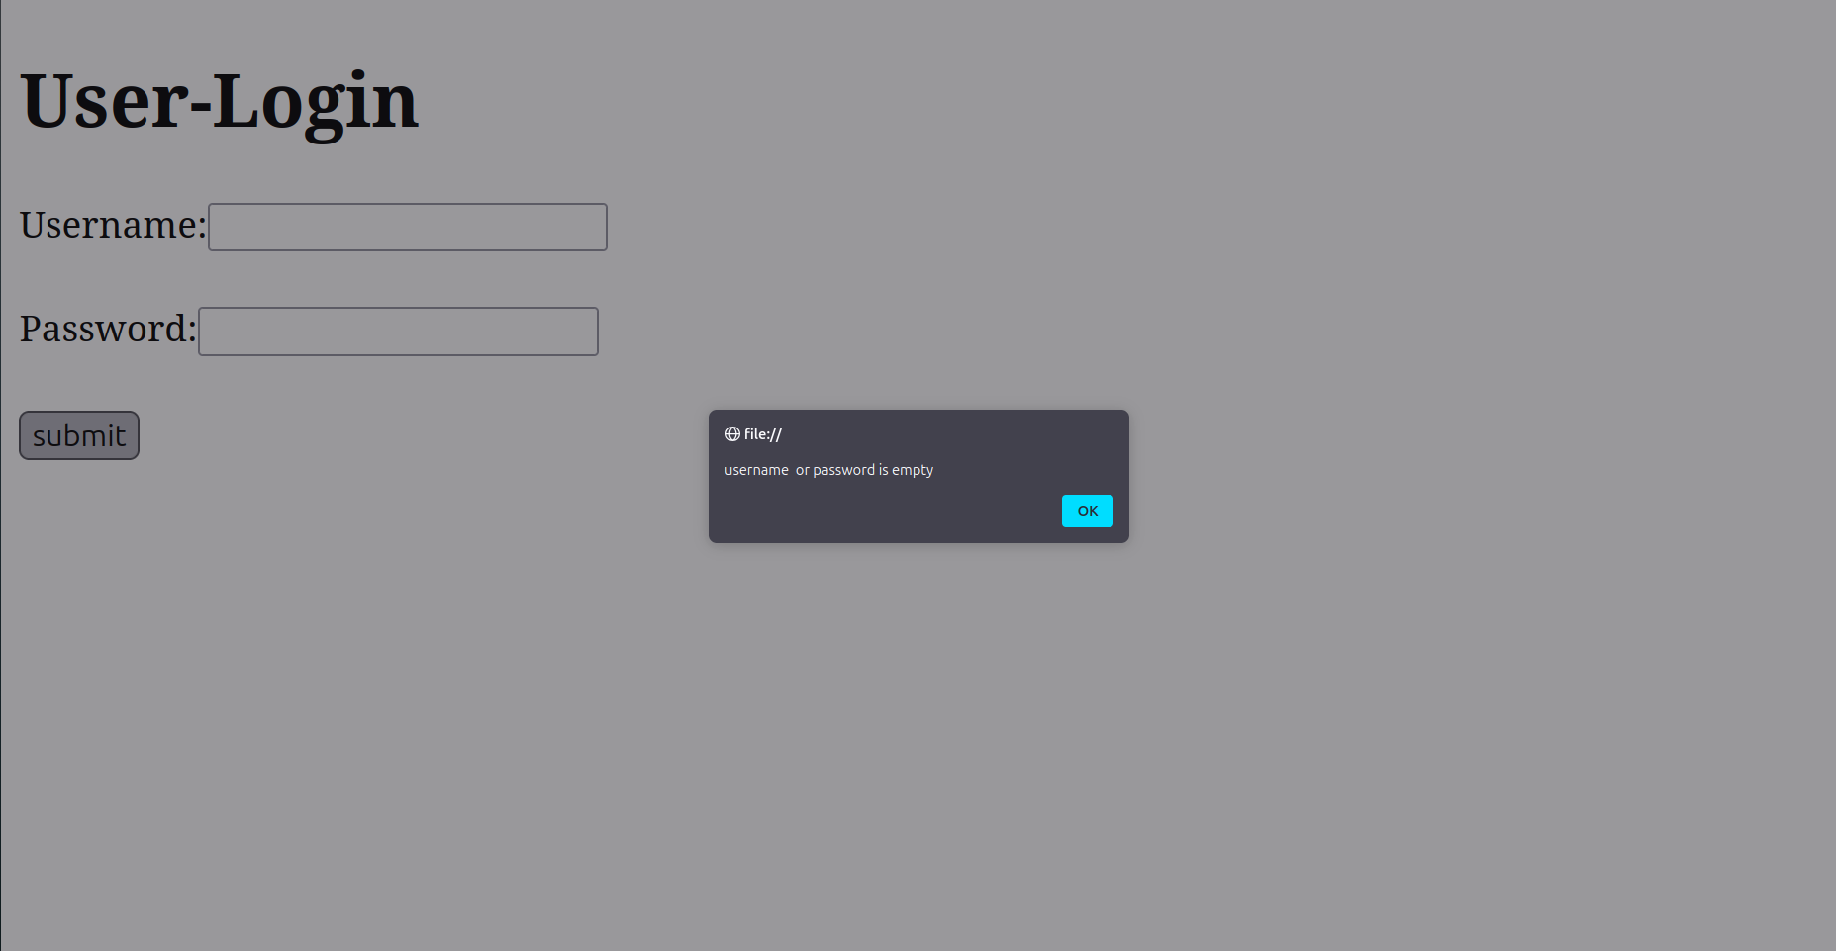

Program 10

Aim
Develop a simple calculator for addition,subtraction,multiplication and division operation using JavaScript.

Program

<!DOCTYPE html>
<html>
<head>
<title>Calculator</title>
<link rel="stylesheet" href="style.css">
</head>
<body>
<h1>Calculator</h1>
<input type="text" size="4" class="inp" id="inp1">
<input type="text" size="4" class="inp" id="inp2"><br><br>
<input type="button"value="+" class="bt" onclick="add()">
<input type="button"value="-" class="bt" onclick="sub()">
<input type="button"value="*" class="bt" onclick="mul()">
<input type="button"value="/" class="bt" onclick="div()">
<br><br>
<span id="res">0</span>
<script>
function add()
{
var a=Number(document.getElementById("inp1").value);
var b=Number(document.getElementById("inp2").value);
var c=a+b;
document.getElementById("res").innerHTML=c;
}
function sub()
{
var a=Number(document.getElementById("inp1").value);
var b=Number(document.getElementById("inp2").value);
var c=a-b;
document.getElementById("res").innerHTML=c;

}
function mul()
{
var a=Number(document.getElementById("inp1").value);
var b=Number(document.getElementById("inp2").value);
var c=a*b;
document.getElementById("res").innerHTML=c;
}
function div()
{
var a=Number(document.getElementById("inp1").value);
var b=Number(document.getElementById("inp2").value);
var c=a/b;
document.getElementById("res").innerHTML=c;
}

</script>
</body>
</html>

Output

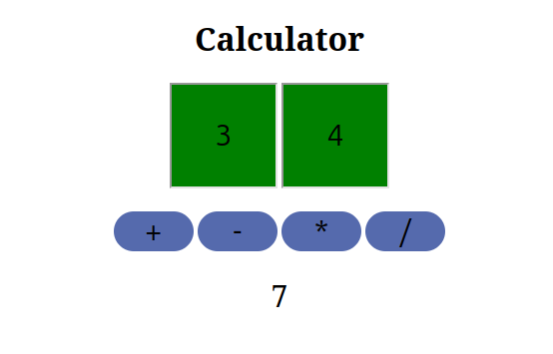

Program 11

Aim
Use Regular Expressions for validations in login Login Page using JavaScript.

Program

HTML

<!DOCTYPE html>
<html>
<head>
<title>Login Page</title>
</head>
<body>
<h1> User-Login</h1>
Email:<input type="email"id="inp1"class="inp"><br><br>
Password:<input type="password" id="inp2" class="inp"><br><br>
<input type="button" value="submit" onclick="validate()">
<script src="script1.js"></script>
</body>
</html>

JavaScript

function validate(){
var email=document.getElementById("inp1").value;
var password=document.getElementById("inp2").value;
var emailPattern=/^.+@.+$/;
if(email.trim()=="")
{
alert("email is empty");
}

else if(!emailPattern.test(email))
{
alert("invalid email format");
}
if(password.length<8 || password.length>12)
{
alert("password must between 8 and 12 characters!");
}
}

Output

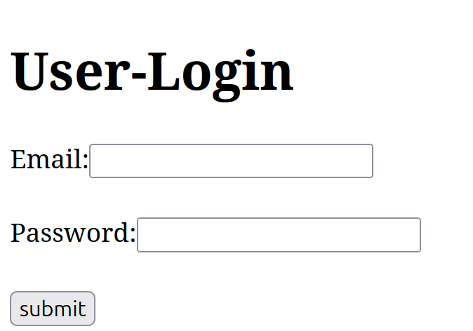

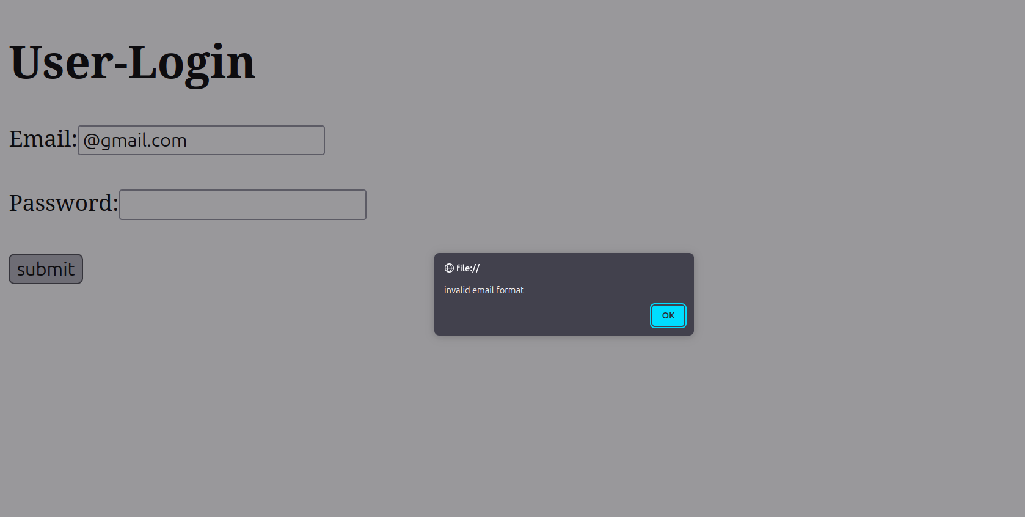

Program 12

Aim
Write program to retrieve data from a text file and display it using AJAX.

Program

<!DOCTYPE html>
<html>
<head>
<title>Ajax</title>
</head>
<body>
<input type="button" value="load date" onclick="loadDate()">
<p>Date:<span id="text"></span></p>

<script>
function loadDate()
{
let xhr = new XMLHttpRequest();
xhr.open("GET","date.txt",true);

xhr.onload= function()
{
if(xhr.status===200)
{
document.getElementById("text").innerText=xhr.responseText;
}
};
xhr.send();
}
</script>

</body>
</html>

date.txt
----------
08-11-2024

Output

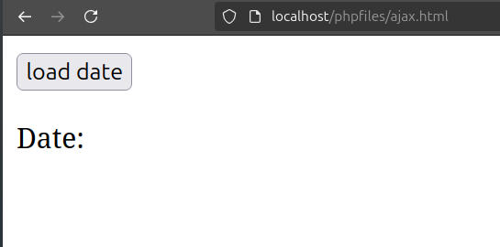

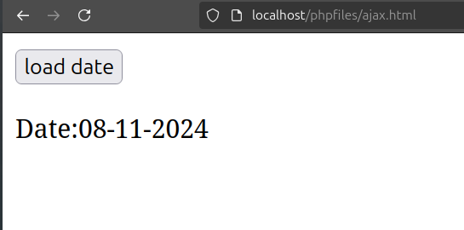

Program 13

Aim
Create a web page using Frame with rows and columns where we will have header frame,left frame,right frame,and status bar frame.On clicking in the left frame ,information should be displayed in the right frame.

Program

Frame.html

<!DOCTYPE html>
<html>
<head>
<title>frame</title>
</head>
<frameset rows="10%,*,10%">

<frame name="header"src="header.html"/>
<frameset cols="25,75">
<frame src="left.html"/>
<frame name="right"/>

</frameset>
<frame name="status" src="status.html"/>
</frameset>
</html>

left.html

<!DOCTYTPE html>
<html>
<head>
<title>left frame</title>
</head>
<body>
<ul>
<li><a href="https://sgcaruvithura.ac.in/" target="right"> SGC Aruvithura </a></li>
<li><a href="https://sgcaruvithura.ac.in/about-department?type=Department%20of%20Computer%20Applications%20(Aided)&department=14" target="right">BCA-Aided</a></li>
</ul>
</body>
</html>

header.html

<!DOCTYPE html>
<html>
<head>
<title>header</title>
</head>
<body>
<h1>Welcome to this site</h1>
</body>
</html>

status.html

<!DOCTYPE html>
<html>
<head>
<title>status</title>
</head>
<body>
<h3>Thank you for visiting</h3>
</body>
</html>

Output
